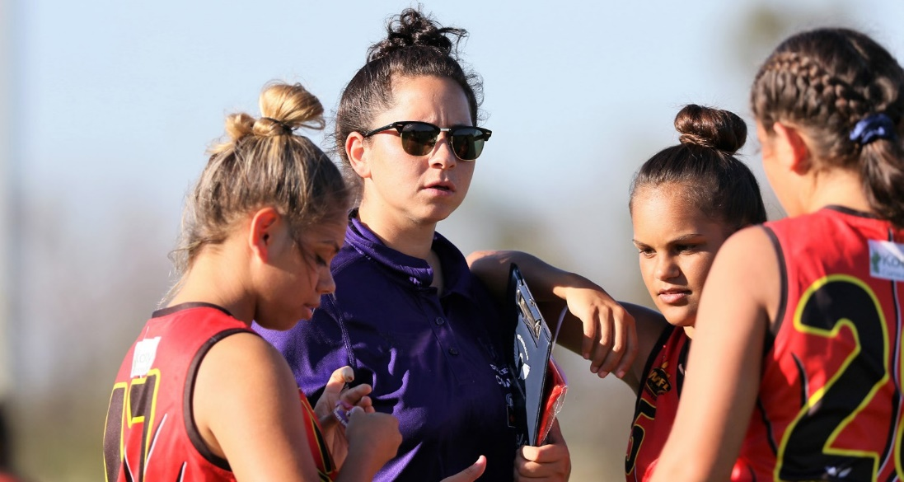
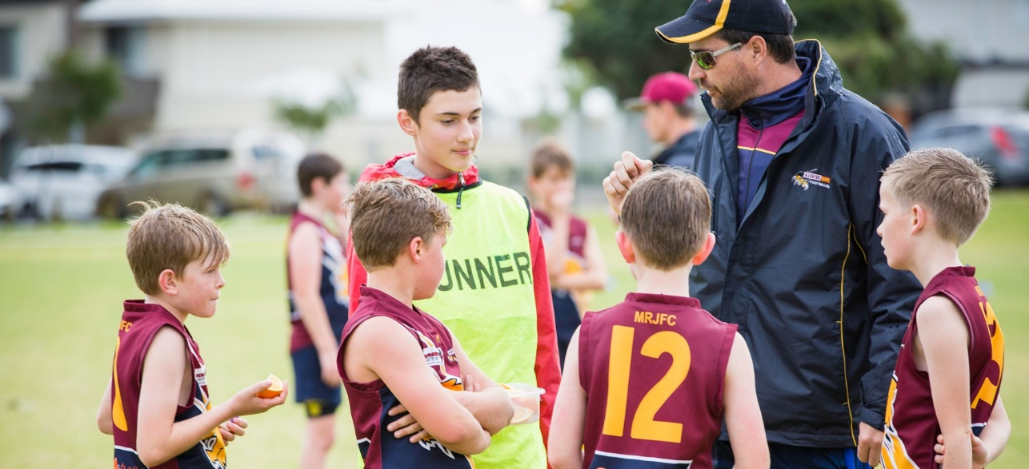



“Growing our Great Game”






VOLUNTEERS

SUPPORTING THE HEARTBEAT OF COMMUNITY FOOTY

INSERT CLUB NAME

CLUB LOGO

VOLUNTEER MANAGEMENT ACTION PLAN

MONTH YEAR

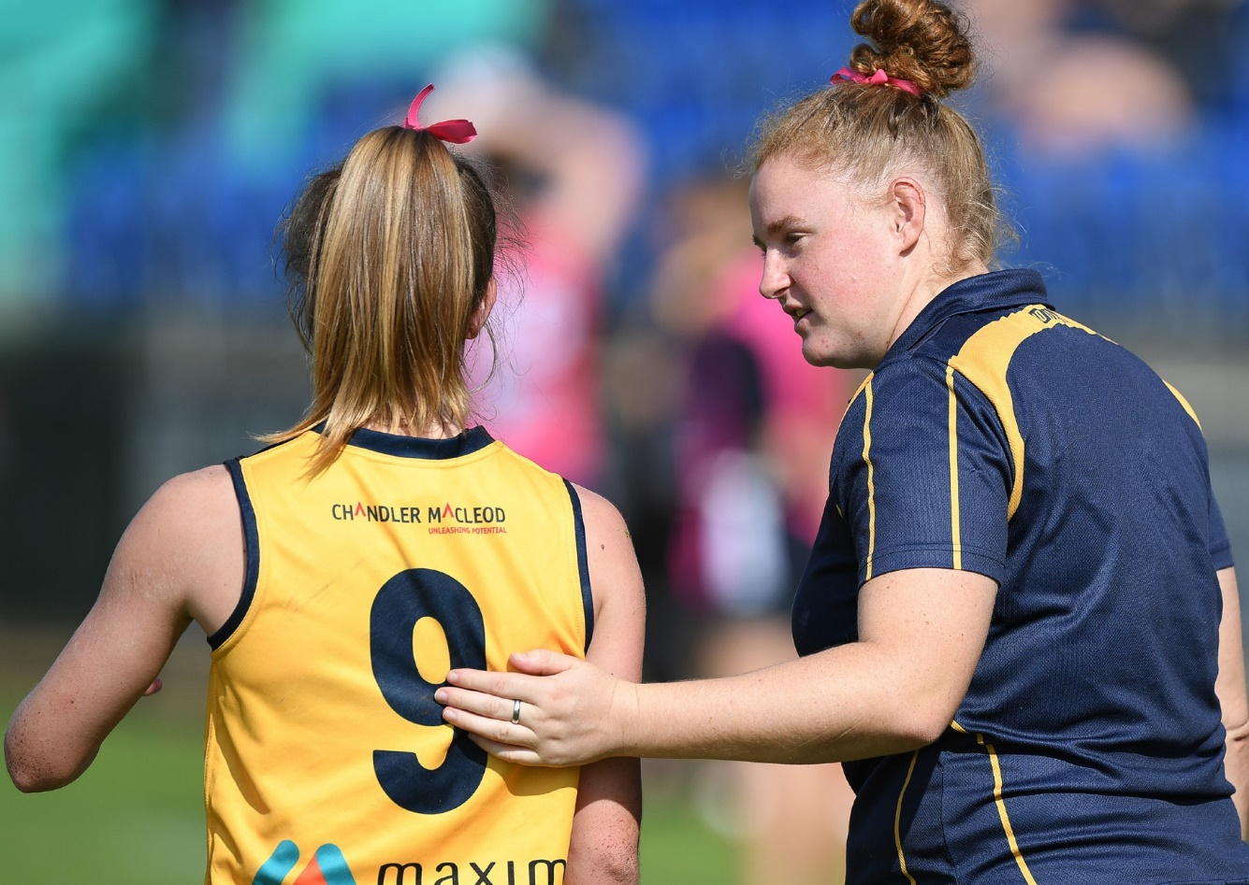




CONTENTS

Volunteer Management Action Plan
Action Plan 03
Football Club Profile 04
Tracking your Volunteer Success Stories 05
Contacts 05
Understanding Volunteering 06
Volunteer Coordinator 07
Stage 1: Recruit 08
Stage 2: Select & Screen 09
Stage 3: Induct 10
Stage 4: Train 11
Stage 5: Recognise & Reward 12
Stage 6: Retention 13
Stage 7: Succession Planning 14
What can I do now with my Volunteer Management Action Plan? 15

02


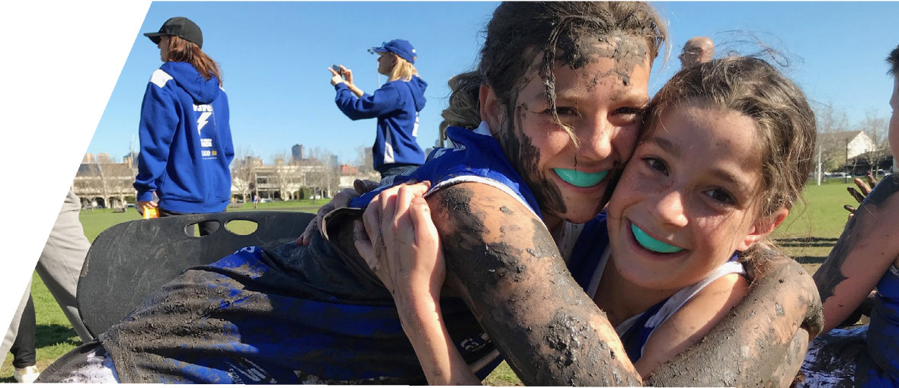

VOLUNTEER MANAGEMENT ACTION PLAN

Action Plan for the West Australian Football Commission
Please note, the Volunteer Management Action Plan can be used by Community Football Clubs. However, minor adjustments may need to be made for the Action Plan to suit the Club.

A Volunteer Management Action Plan provides the West Australian Football Commission with clear objectives and strategies to support volunteer recruitment and retention efforts. Supporting, recognising, and rewarding volunteers is crucial for the ongoing sustainability of clubs. The Volunteer Management Action Plan will assist in achieving effective Club structures and management practices.

The Volunteer Management Plan has two core functions:
- Recruiting Volunteers; and
- Retaining Volunteers.

Both functions are continuous and must work in conjunction with each other to be the most effective. The success of the plan is dependent on the commitment demonstrated by the club towards improving a volunteer’s experience in football.

The Volunteer Management Cycle (Figure 1) outlines the on-going process Clubs need to implement; bringing volunteers into the Club, looking after them while they fulfil their duties and then planning for when they leave.



VOLUNTEER MANAGEMENT CYCLE
1
RECRUIT
7
SUCCESSION PLANNING
2
SELECT & SCREEN
3
INDUCT
6
RETENTION
VOLUNTEER
MANAGEMENT CICLE
5
RECOGNISE & REWARD
4
TRAIN

VOLUNTEER MANAGEMENT ACTION PLAN

INSERT NAME Football Club Profile

District

INSERT DISTRICT NAME

Year Established

INSERT YEAR

Home Ground

INSERT CLUB HOME GROUND

Website

INSERT CLUB WEBSITE

Social Media Accounts

INSERT CLUB SOCIAL MEDIA ACCOUNTS

Club Vision

INSERT CLUB VISION

Example: To be a safe, inclusive and welcoming community club that allows people to engage with the game of football.

Club Values

INSERT CLUB VALUES

Example: Inclusive, Accountability, Excellence, Teamwork, Honesty and Trust, etc.

Number of Volunteers

INSERT NUMBER OF CLUB VOLUNTEERS

Number of Life Members

INSERT NUMBER OF CLUB LIFE MEMBERS

Sponsors

INSERT CLUB SPONSORS

CLUBS MAY WANT TO ACKNOWLEDGE
LOCAL COUNCIL

CLUBS MAY WANT TO ACKNOWLEDGE
LOCAL COUNCIL

TRACKING YOUR VOLUNTEER SUCCESS STORIES
It is crucial to understand the success your Club has had after the development of the Volunteer Management Action Plan. It is just as important to continue to identify any volunteering gaps and track how your Club is managing the Volunteer Management Cycle.
Against each of the segments of the Volunteer Management Cycle in the Club plan, it is important to mark against the goal how the Club is tracking.


Here is a key that will assist in tracking the implementation of your Volunteer Management Action Plan.
 NOT STARTED  IN PROGRESS COMPLETED
Your local WAFC District Staff Member is available to assist you with your Volunteer Management Action Plan. The WAFC staff are encouraged to work with your Club to complete the plan and provide ongoing support.
DISTRICT CONTACTS

Jessie Barker jbarker@wafc.com.au




Andrew Ridley aridley@wafc.com.au


Aidan Lynch alynch@waf.com.au
FALCONS
"Growing our Great Game"




Zac Binning zbinning@wafc.com.au
ROYALS


Zee Schorsch zschorsch@wafc.com.au
PERTH
“Growing our Great Game”

Josh Embry
jembry@wafc.com.au


Bradd Gardner bgardner@wafc.com.au


PEEL
Jesse Tippet
jtippet@wafc.com.au


Pierce Dawson pdawson@wafc.com.au

BULLDOGS


UNDERSTANDING VOLUNTEERING

Remember, most people are willing to volunteer, they just need to be asked,

What defines a volunteer?

Volunteers are representatives from the community who freely choose to give their time and skills to support club activities for no payment other than reimbursement for out-of- pocket expenses.

If you want to increase the number of volunteers at your club, understanding what motivates people to be involved and what prevents people from donating their time and energy is critical.

WHY DO PEOPLE VOLUNTEER? | WHAT STOPS PEOPLE FROM VOLUNTEERING?
- Meet new people  - Learn new skills  - Gain work experience  - Fun and enjoyment  - To make a difference in their community  - Being part of a team with a common goal, “belonging to something”  - Being involved and spending time with their child or family member  - Being seen as a role model | - Lack of time  - The possibility of out-of-pocket expenses  - Not knowing what opportunities exist  - The belief they are not skilled enough to help  - Assuming that football knowledge is required  - Increasing expectations from the club  - Having a disability  - Health or personal issues  - Feeling shy / lack of confidence  - Fear of being criticised or making mistakes

06



VOLUNTEER COORDINATOR
It is recommended to appoint a Club Volunteer Coordinator who will be responsible for the recruitment, management, and retention of volunteers.

The volunteer coordinator needs to be a good organiser, with plenty of time and energy to look after volunteers and to match the skills and experiences of all volunteers with an appropriate position at the club.

RESPONSIBILITIES

PRE-SEASON | SEASON | POST-SEASON
- Assess the volunteer needs  - Develop clear job descriptions for all required tasks  - Attract and recruit new volunteers to the club ensuring the right person is found for each job  - Organise volunteer induction and training  - Roster volunteers for pre-season games and/or events | - Supervising volunteers or allocate other members to supervise  - Roster volunteers for all game day and season events  - Regularly check in with volunteers to ensure volunteers are happy and have opportunity to provide feedback  - Identify and organise training and education opportunities  - Recognise and promote the efforts of volunteers e.g., weekly profiles  - Communicate and liaise with committee members as required | - Conduct volunteer survey  - Review job descriptions and work instructions and update where required  - Recognise volunteer efforts and thank them
For further information on how to create a Volunteer Coordinator PD, visit www.afl.com.au/clubhelp.

07

STAGE 1. RECRUIT
Recruiting the right people into the right roles at your Club is vital. This can include identifying tasks and roles, the time and number of volunteers required, who does the task and role now, and when it will finish.

STRATEGY OR ACTION | TIMELINE |  | ACTION OFFICER | COMMENTS
STRATEGY OR ACTION | GOAL | STATUS | ACTION OFFICER | COMMENTS
Create a database of your current volunteers. | Place volunteers in roles that are best suited to their area of expertise. |  | Club Committee | Include their skills, interest areas and other relevant information.  Encourage Volunteers to register on PlayHQ. Add interest areas field, etc. to the Registration Page for volunteers.
Create a list of current and future roles within your clubs | Identify roles that are required within the club’s organisation structure. |  | Club Committee | Include game day requirements, special events like pre-season launches, committee positions, and other operational requirements at your club.
Review your database and your list of roles. | Determine where you have surplus/ shortage of volunteers. |  | Club Committee | Ensure you are recruiting volunteers in the right area.
Develop/ update role descriptions for each position. | Provide clarity around what a volunteer will be asked to do and remove potential barriers preventing someone from volunteering. |  | Club President | Job descriptions should include volunteer position title, required time commitment, skills needed and the tasks the volunteer will be required to complete.
Find and appoint volunteers. | Promote and advertise volunteer role opportunities. |  | Club Committee | Identify different platforms for promotion (club website, social media, Volunteering WA job board, registration forms)
Become a Duke4Sport Partner | Enhance the club’s ability to secure regular on- going volunteers. |  | Club Committee | Encourage young volunteers from outside the club.

NOT STARTED  IN PROGRESS  COMPLETED

STAGE 2. SELECT & SCREEN
The process of promoting the tasks to be completed, attracting volunteers to do the tasks, screening volunteer’s suitability to perform the task, and selecting and appointing volunteers to roles.

STRATEGY OR ACTION | TIMELINE |  | ACTION OFFICER | COMMENTS
STRATEGY OR ACTION | GOAL | STATUS | ACTION OFFICER | COMMENTS
Develop a simple and efficient selection process. | Selection process is used for each new volunteer according to the type of role/ activity. |  | Club Committee | Having a selection process helps to ensure you get the right person for the role. Depending on the role, you may decide whether a formal/informal process is appropriate, whilst keeping the overall process simple.
Volunteers assessed against the position description. | Each volunteer is placed in activities that suit their skills, interests, knowledge, and experience. |  | Volunteer Coordinator | Specific screening requirements will be detailed in the position description.
Develop/Update screening process. | Ensure all volunteers meet Child Safeguarding requirements. |  | Volunteer Coordinator | Volunteers will need to adhere to appropriate screening including, if applicable, the Working with Children Check and/or a National Police Certificate.
Maintain records of all volunteers’ details and WWC/NPC. | Create a Volunteer Register including volunteers’ details, WWC numbers and/ or National Police Checks. |  | Volunteer Coordinator | Clearly outline all club volunteers in a document to make it easier to edit/make changes. The Club is also upholding its legal responsibility to keep current records of its volunteers.
NOT STARTED IN PROGRESS COMPLETED

STAGE 3. INDUCT
The process of welcoming volunteers to the Club, informing volunteers of Club policies and procedures, and establishing preferred communication methods.

STRATEGY OR ACTION | TIMELINE |  | ACTION OFFICER | COMMENTS
STRATEGY OR ACTION | GOAL | STATUS | ACTION OFFICER | COMMENTS
Develop a formal orientation and induction process. | Ensure volunteers understand their role and responsibilities within the organisation and have knowledge to perform their voluntary role as required. |  | Club Committee | The club is responsible for ensuring that all volunteers are properly inducted and have the necessary information, resources, and knowledge to perform their role.
Induct new volunteers. | Develop an induction checklist for all new volunteers entering the football Club that includes codes of behaviour, policies, and procedures. |  | Club Committee | The checklist supports the new volunteer orientation to be thorough and consistent regardless of who conducts it.
Ensure that all new and existing volunteers feel that they are part of the Club. | Ensure that all communication lines are open from the President down. |  | Club Committee | It’s important that all volunteers feel like they are a part of the Club. This will improve the Club’s image within the community and more volunteers will want to get involved.
NOT STARTED IN PROGRESS COMPLETED

STAGE 4. TRAIN
Educating volunteers on specific information for the role, and additional learning and development opportunities to enhance knowledge and skills.

STRATEGY OR ACTION | TIMELINE |  | ACTION OFFICER | COMMENTS
STRATEGY OR ACTION | GOAL | STATUS | ACTION OFFICER | COMMENTS
Provide pathways to communicate information to volunteers. | Develop useful tools such as website, Twitter, and Facebook.  These are known as the main information source for internal and external users. |  | Communications Administrator | Communication is vital to all members and potential new members. Sending information through various social media channels makes for a wider reach.
Encourage and pay for volunteers to attend courses that will benefit the Club. | Pay for all coaching courses and out-of- pocket expenses the clubs deem reasonable for reimbursement. |  | Club Committee/ Treasurer | The Club currently encourages and pays for new volunteers and coaches to take part in courses to improve their skills.
Volunteer Feedback | Create an end of season volunteer survey to give volunteers an opportunity to provide feedback. |  | Volunteer Coordinator | Assists in evaluating your club’s volunteer management techniques as well as retention of volunteers.
NOT STARTED IN PROGRESS COMPLETED

STAGE 5. RECOGNISE & REWARD
The process of acknowledging a volunteer’s contribution.

STRATEGY OR ACTION | TIMELINE |  | ACTION OFFICER | COMMENTS
STRATEGY OR ACTION | GOAL | STATUS | ACTION OFFICER | COMMENTS
Promote the WA Football Volunteer of the Year award. | Encourage all members to nominate volunteers. |  | Volunteer Coordinator | Work with your local District Officer in nominating your volunteers for the listed categories.
Develop a Volunteer Awards Program to be included in the end-of-year celebrations. | Plan for volunteer awards.  Recognise volunteers at the conclusion of the season. |  | Volunteer Coordinator | Make sure every volunteer is recognised in some way. A small piece of recognition may determine if the volunteer continues.
Develop a Volunteer Appreciation Calendar. | Identify key times in the year to thank volunteers for their on-going support and dedication. |  | Volunteer Coordinator | Continually promote the efforts of the volunteers throughout the year (not just at the end of the season).
Recognise Life Members. | Induct Life Members into the Football Club. |  | Club Committee | The importance of recognising volunteers who have contributed and deserve Life Membership is imperative.  Recognising previous Life Members might be a way to attract old and new volunteers back.
Develop a budget for recognising volunteers. | Allocate a portion of money for volunteer recognition. |  | Club Committee / Treasurer | Allocating money for volunteer recognition will dismiss ad-hoc awards and recognition.
NOT STARTED IN PROGRESS COMPLETED

STAGE 6. RETENTION
It’s important to understand why someone might volunteer for your club to ensure volunteering is attractive and fulfilling as possible.

STRATEGY OR ACTION | TIMELINE |  | ACTION OFFICER | COMMENTS
STRATEGY OR ACTION | GOAL | STATUS | ACTION OFFICER | COMMENTS
Understand why someone might volunteer for your club. | Create volunteering opportunities that are attractive and fulfilling. |  | Club Committee | It is much easier to keep volunteers than it is to recruit new volunteers.
Understand the barriers to volunteering. | Survey current volunteers within the club to get a better understanding of what may/may not be working within your club. |  | Volunteer Coordinator | Make it easy as possible for volunteers to volunteer.
Create a Volunteer Roster. | Ensure each role within the club is filled and all duties covered during game days and special events. |  | Volunteer Coordinator | Rostering is an important element of the volunteer management process. It will help volunteers know when they are required and for how long.
NOT STARTED IN PROGRESS COMPLETED

STAGE 7. SUCCESSION PLANNING
Succession planning is about putting systems in place to ensure smooth club operation and transition of new volunteers as old volunteers leave the club.

STRATEGY OR ACTION | TIMELINE |  | ACTION OFFICER | COMMENTS
STRATEGY OR ACTION | GOAL | STATUS | ACTION OFFICER | COMMENTS
Examine the club’s position. | Identify the vital roles that play a part in the current and future success of the club. Make a list of these roles, and the responsibility and skills required by the roles. |  | Club Committee | For those roles that are currently filled, identify when that role may become vacant due to people relocation, retiring, constitution requirements for position turnover of any other reason.
Identify skills required to fill critical roles in your club | Create position descriptions for each role. |  | Club Committee & current volunteers | Position descriptions are crucial to affective succession planning and ensure the right person is found for the role.
Identify potential successors. | Ensure there is a new person waiting in the wings when the current person moves on. |  | Club committee & current volunteers | Compare skills required for the role with the skills of current volunteers. This will help identify potential successors and determine whether the club may need to look externally.
Develop and prepare potential successors. | Create a training and development plan. |  | Club Committee | It is recommended that training and development is still provided to ensure they can confidently step into the role when required.
Evaluate your succession plan. | Set measurable indicators. |  | Club Committee | By monitoring performance and being aware of changes, your succession plan will be more effective, more relevant, and more valuable.
NOT STARTED IN PROGRESS COMPLETED

WHAT CAN I DO NOW WITH MY VOLUNTEER MANAGEMENT ACTION PLAN? MANAGEMENT
The process in which a Club now utilises the plan to its full potential.

INFORM AND SHOW THE MEMBERS AND VOLUNTEERS AT THE CLUB

START TO IMPLEMENT PARTS OF THE PLAN INTO YOUR CLUB

WHAT DO WE DO NOW WITH OUR VOLUNTEER MANAGEMENT ACTION PLAN?

INFORM THE LOCAL DISTRICT OFFICER AND SEEK ADVICE IF NECESSARY

PLACE IT ON THE WEBSITE

For additional information and resources on Volunteer Management visit the Toyota AFL Club Help website – www.afl.com.au/clubhelp.
























ROYALS

PEEL
PERTH
“Growing our Great Game”
BULLDOGS FALCONS
"Growing our Great Game" 15

