WAFC NAIDOC ROUND 2020
Preamble
The WAFC suggests that prior to the game commencing, teams are asked to form 2 lines in front of interchange and spectators prior to the game. Like so.
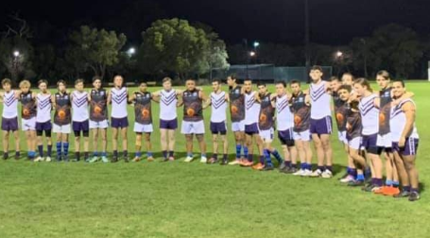
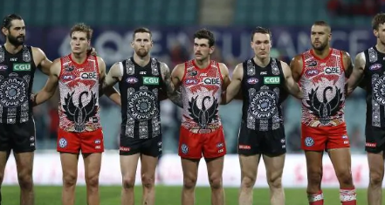

Umpires can do their pre-game checks on hands/boots, etc. The umpire can give pre-game talk on “how the game should be played”.
The home team official or senior umpire can then make the following statement:
“The West Australian Football Commission and _____________________ Junior Football Club & ______________________ Junior Football Club would like to acknowledge that we are meeting here today at [name of venue] which is on the traditional lands of the Noongar people [Change to reflect local context]. On behalf of the WA Football Family, I pay our respects to the elder’s past, present and emerging and thank them for their contribution to our great game.
Today we celebrate NAIDOC ROUND in embracing the history, culture, and achievements of Aboriginal and Torres Strait Islander peoples. Suggestion is to invite a local Aboriginal and Torres Strait Island Elder or Community member to toss the coin
We also stand here united today against racism of any kind.
This stance symbolises that we will not tolerate racism in our game, in any form and we will call it out whenever we come across it. This is a responsibility that we must all share”

The umpire shall blow whistle and thank everyone.

