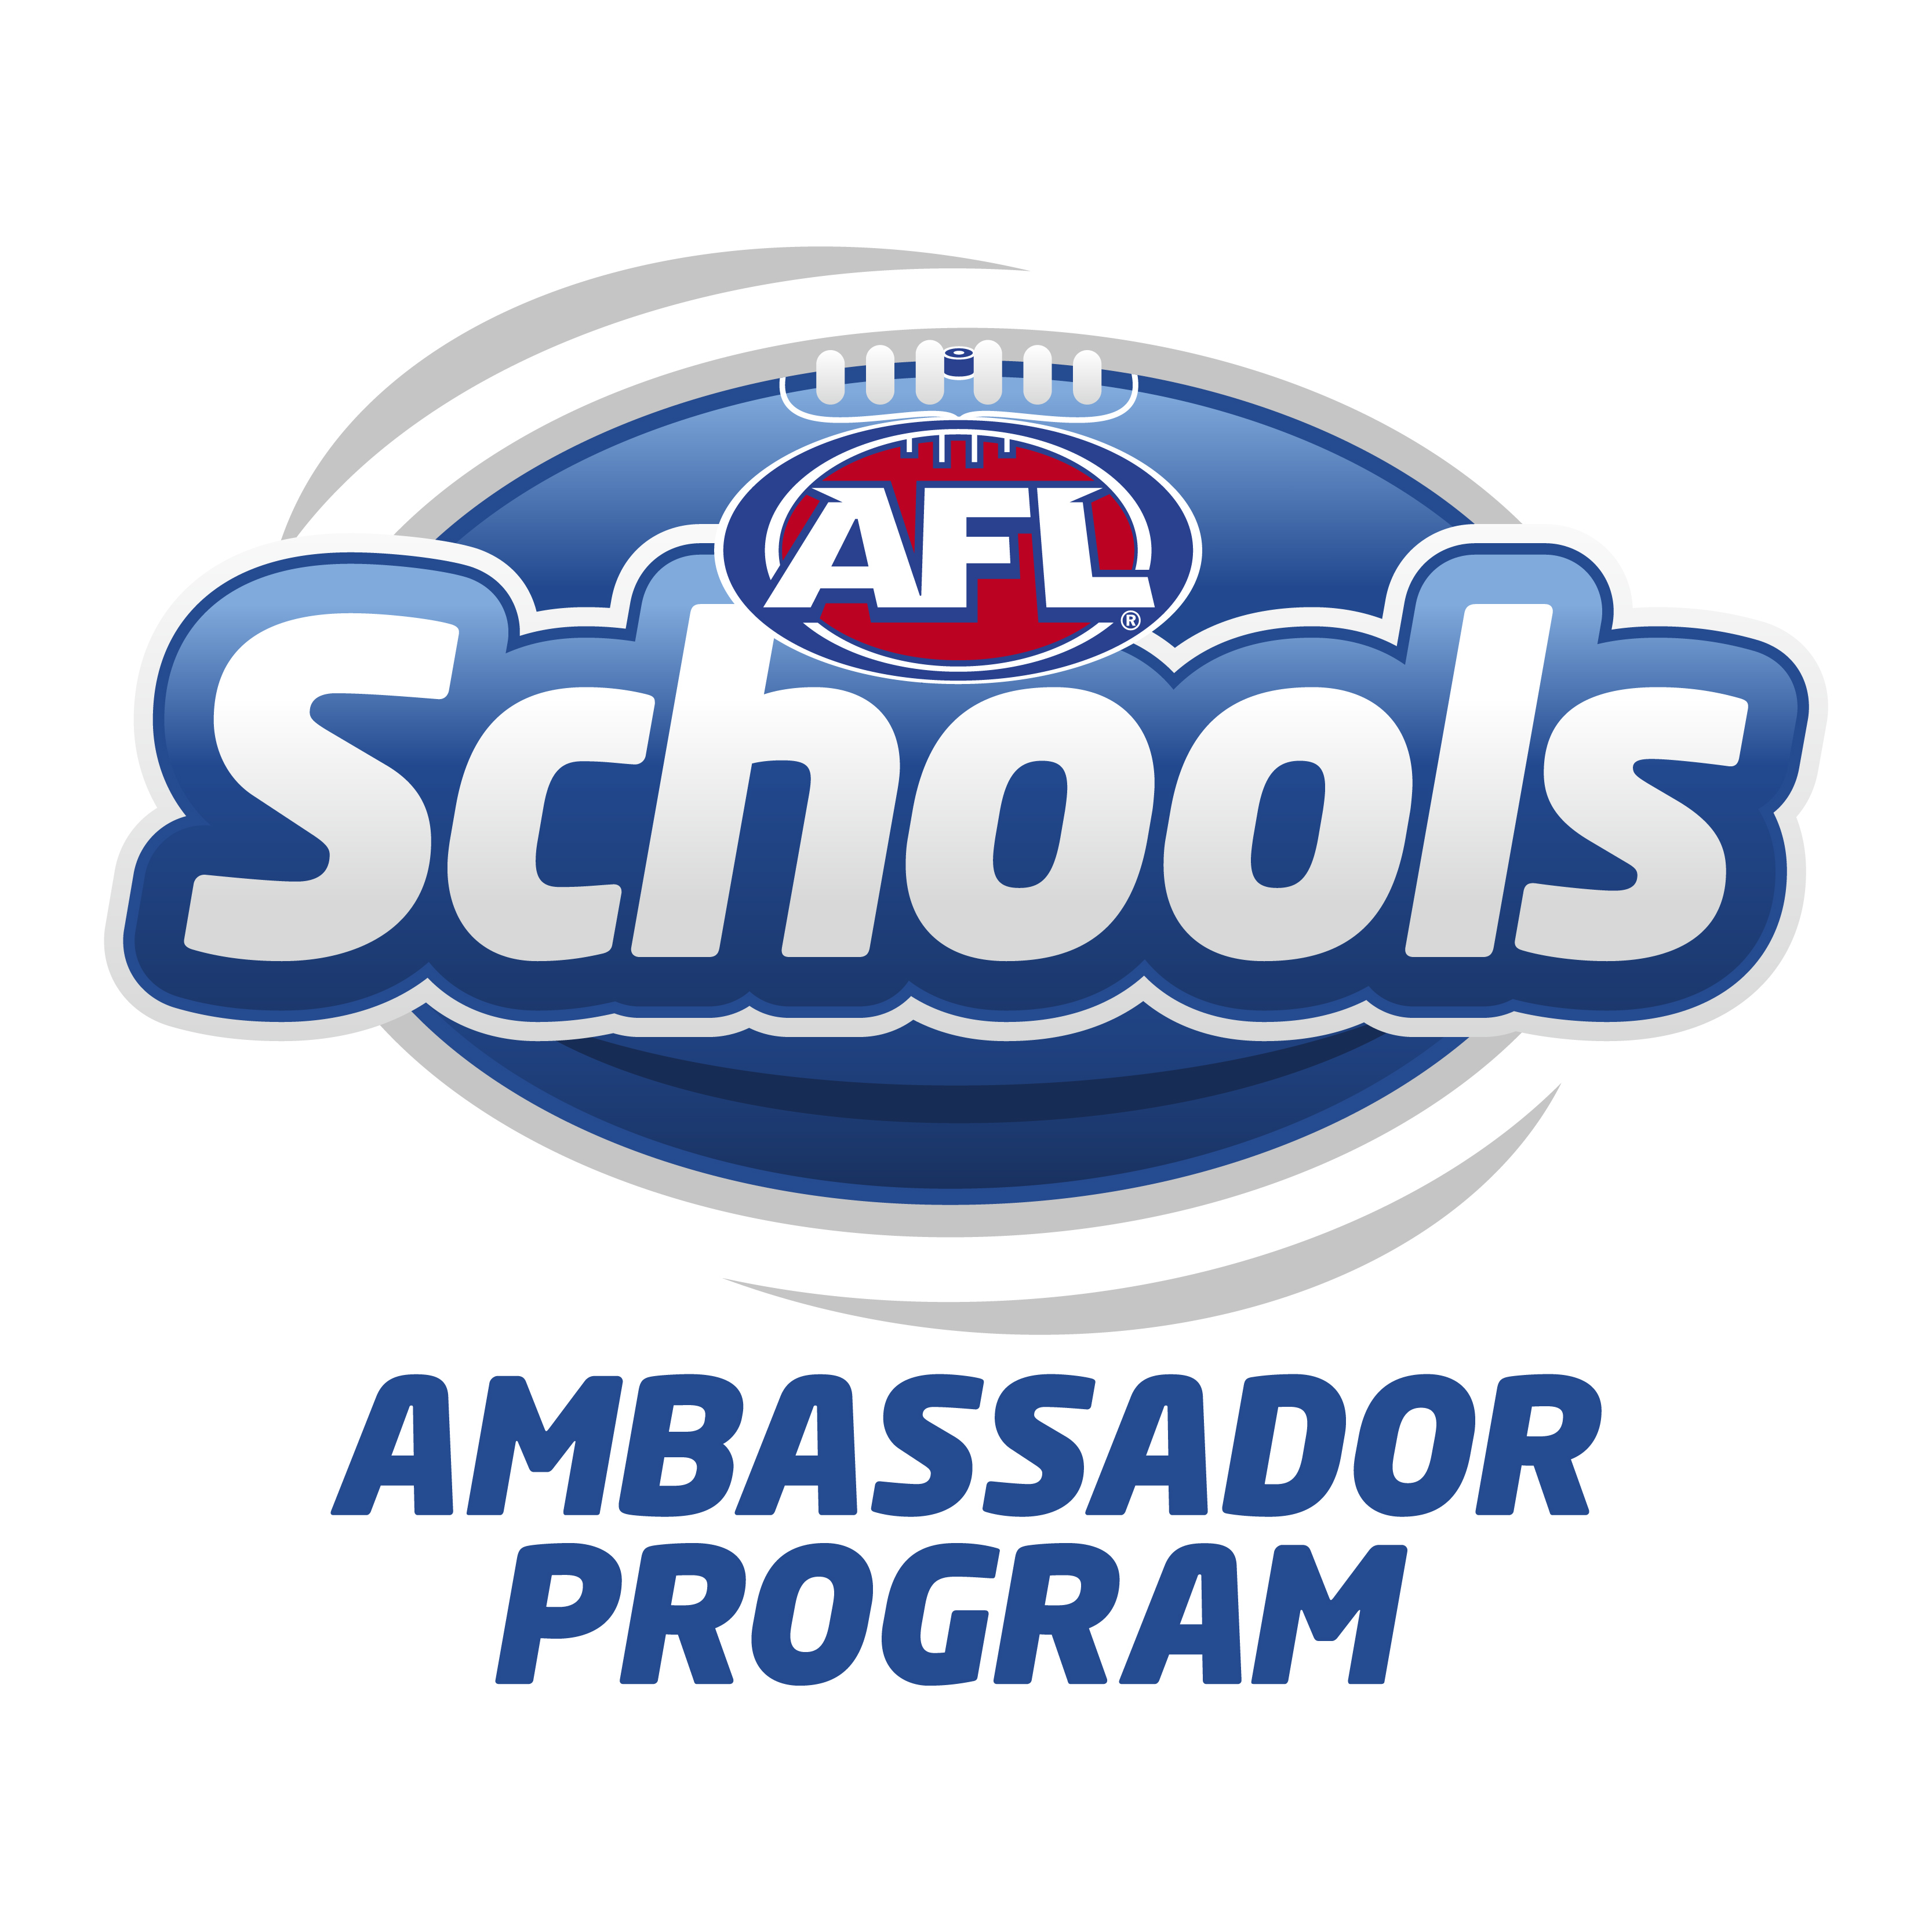

AFL Jumpers Grant
Application Form

Thankyou for registering your interest in the 2018 Jumper Subsidy program offered by the WAFC. Please fill in the below form and return it via email. You will receive an email if you are successful in obtaining the subsidy. The subsidy will be for a minimum of $500. Jumpers are to be purchased through our supplier Burley Sekem with a set of 25 jumpers costing $880.

School Name: ______________________________________________________

Address: ______________________________________________________

______________________________________________________

Suburb: _____________________________Post Code __________

Phone: _______________________ Fax: ________________________

Email: ______________________________________________________

In order for your school to be successful in the AFL subsidy; you must meet the following criteria.

This School IS participating in competitions of at least 4 weeks in duration in 2017 as follows:
See the WA Football Commission web page and visit the ‘schools’ tab for more information on competitions you can participate in.

______________________________________________________________________________

How will the grant lead to a potential growth in football participation and benefit the school?

______________________________________________________________________________

______________________________________________________________________________

____________________ ______________________
Name of Applicant Name of Principal

_____________________________ _______________________________ ___________________
Signature of Applicant Signature of Principal Date

If approved by WAFC, the school is to purchase a set of 25 AFL Jumpers through Burley Sekem (Email Glen – glen@sekem.com.au or call (08) 9270 5400) and forward a copy of the invoice to the WAFC for reimbursement.
*NOTE - WAFC will make a contribution towards the costs incurred. The amount depends on the number of successful applicants. The school will then invoice the WAFC for the amount provided.

Applications for funding close on May 18th, 2018.
All schools will be notified by June 8th on funding distribution for 2018.

Please send or email your application with the necessary information to:

ANDREW KING
Community Football Coordinator
P: 9287 5548
E: aking@wafc.com.au

DAVID LINDSAY
Schools Manager
P: 9287 5590 E: dlindsay@wafc.com.au

