IN ASSOCIATION WITH

XXXXXXX ENTER LEAGUE LOGO HERE XXXXXXX

INVITATION FOR
XXXXXXX ENTER PARTNER NAME HERE XXXXXXX
TO PARTNER WITH THE XXXXXXXXXXX FOOTBALL LEAGUE

DATE:
XX/XX/XXXX

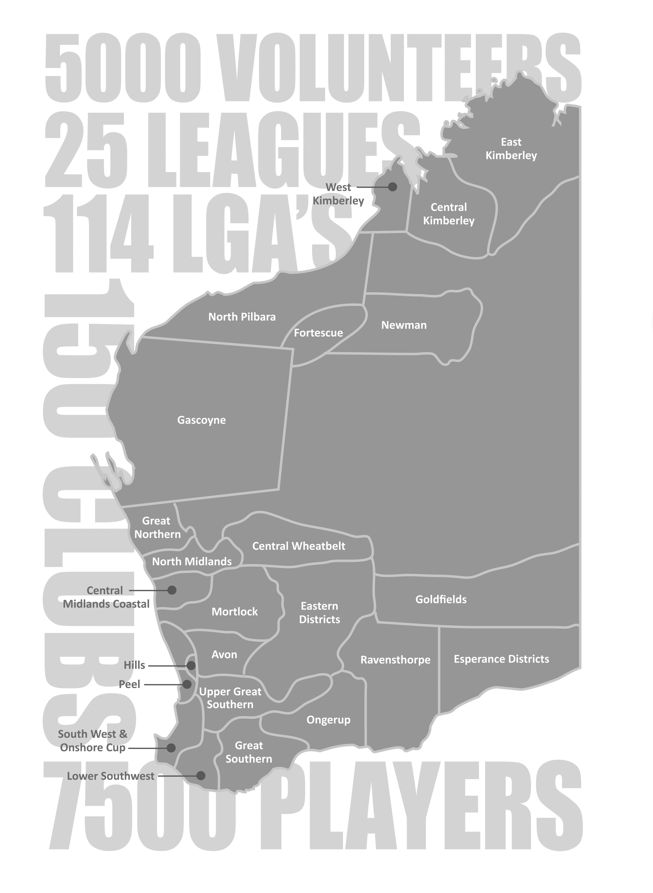
Our Vision
The West Australian Country Football League’s (WACFL) vision is to enhance regional communities through having professionally run football competitions where participants are able to develop within a safe, well governed and successfully administered environment.
Community
Country Football not only provides the state’s regional population the opportunity to participate in a professionally administered sporting competition, but also provides communities with consistent social occurrences that as well as providing entertainment to the community are significant economic drivers.
In 2010 WACFL engaged Street Ryan to carry out a study into the economic impact of football. This report was titled Central Wheatbelt and Great Northern Country Football Economic Impact 2010.
The report stated that the annual economic contribution of local football in the Central Wheatbelt and Great Northern districts in 2010 was estimated to be $4.41 million:
- $1.90 million in Central Wheatbelt and
- $2.51 million in Great Northern.
Using the above two leagues as an average, you could assume that the state-wide economic contribution of senior country football regionally was upwards of $40 million per annum.
Country football has also taken a leadership role within the community using our strong profile to educate players, volunteers, spectators and the community at large on issues such as road safety, men’s health and mental health.
Profile
Across the state, football is the predominant sport. This is especially true in regional Western Australia where other codes have had great difficulty establishing a presence due to football’s stronghold.
As well as the profile of the AFL, the local AFL clubs and the WAFL competition, country football is something that invokes much passion and discussion in the country as towns play against rival towns and sometimes towns divide to play against themselves. With such passion, country football has a strong position and gains great profile regionally through numerous media outlets (radio stations and print media) and public interest.
Coverage
Australian Rules football is the predominant sport in regional Western Australia. Throughout the state there are 25 senior leagues spread from Kununurra in the north east to Esperance in the state’s south.
There are country football competitions across 114 of the state’s 135 regional Local Government Areas (LGAs).
Senior Football
Senior football competitions are for players from the age of 16 to open age. The structure of a competition varies in each area. Some competitions with a strong population of players have Colts, Reserves and League competitions, whilst smaller regions may only have a League competition.
Each of the WACFL’s 25 senior leagues has its own committee/governance structure to manage its competition including clubs, tribunals, umpiring, fixtures, rulings, etc.
There are over 150 senior country football clubs in Western Australia which equates to between six and seven per league on average. Some clubs have numerous grades whilst others only have one team, dependent on population.
There are over 7,500 registered senior country footballers in WA who play in one of the WACFL’s 25 senior competitions. This is quite a specific market that is:-
- between the ages of 16-40
- male
- resides regionally
- physically active
WACFL estimates there are as many as 5,000 volunteers from around the state who help facilitate football in our 25 senior competitions. Volunteer Jobs may include canteen, line marking, gate keeper, team management, committee person, umpiring, scorer, timekeeper, etc.
There are approximately 2,500 matches of senior country football played each season.
There are approximately 100 matches of senior country football played each weekend between April and September.

Segments
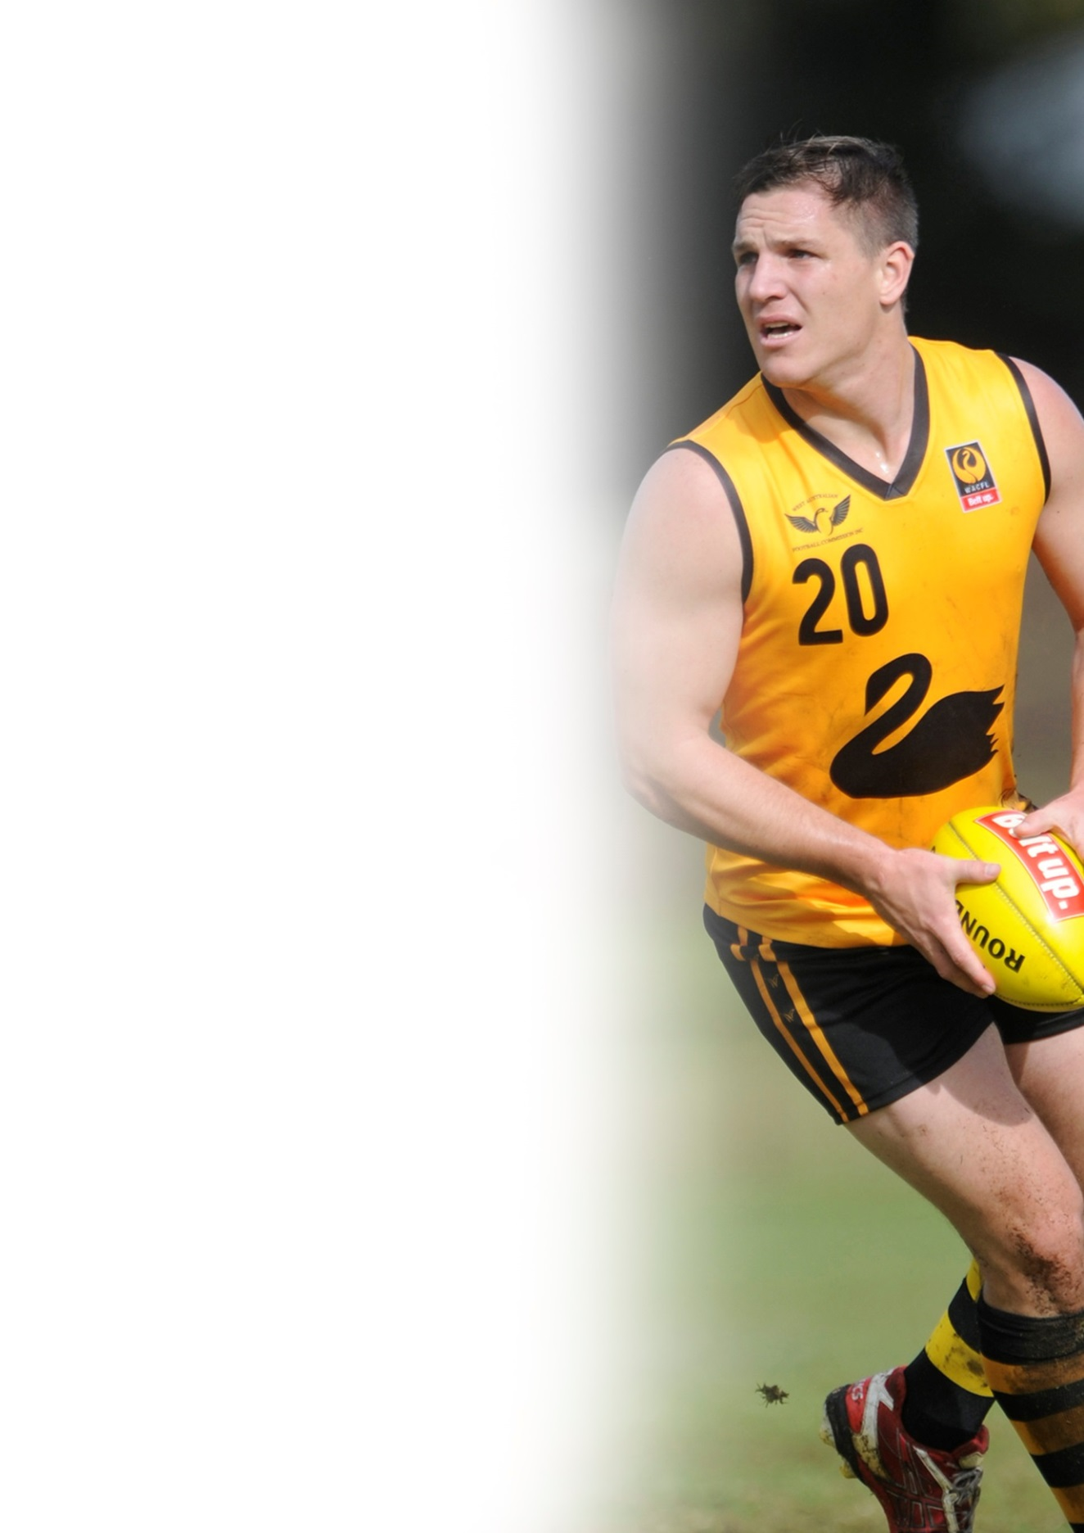
With 25 senior leagues spread throughout the state, Country Football covers a number of targeted segments due to the locations of our leagues and the demographics of our players. Some of these segments are listed:
Young Adult Males - Data suggests that 65% of the WACFL’s 7,500 players are aged between 18 and 25 years.
Agricultural - 14 senior country leagues represent regions that are heavily involved with agriculture as a major source of income for their region.
Mining - A handful of senior country leagues are located in regions such as the Pilbara and Goldfields that are heavily involved in the mining sectors. Non-traditional mining areas of the state such as the Kimberley, Esperance, Albany, Gascoyne, Geraldton, etc., have also expanded into the mining sector in recent years which has had an impact on communities, populations and participation.
FIFO workers have become an increasing demographic of country football which has impacted not only mining towns but all country regions as a result of players working on a FIFO basis from their regional location.
Indigenous - There is a relatively high percentage of indigenous players throughout regional leagues, including areas such as the Kimberley which has predominately indigenous players throughout its leagues.
Regional Hubs - Many of the state’s larger leagues are located in key regional areas with solid populations including: Bunbury, Kalgoorlie, Albany, Geraldton, Broome and Esperance.

Levels of Sponsorship
For state-wide and multi league sponsorships, potential sponsors should speak to the WACFL which, as well as having assets available, is able to coordinate sponsorships across leagues in a professional and coordinated manner.
For local level sponsorships, potential sponsors’ first point of contact should be the league or club president. Each league and club has numerous assets for sale which can be tailored to the needs and business requirements of your business.

The Importance of Sponsorship
By sponsoring Country Football at some level, you are assisting the WACFL, our 25 Leagues and 150 Clubs to continue to support those people who not only play country football, but also help facilitate the competitions at some capacity.
Benefits to a regional community of this investment are many and include:-
- Providing regular social activities for regional and isolated communities
- Promoting a health and fitness culture
- Engaging youth in their community and reducing antisocial behaviour
- Allowing communities to participate in sport for a subsidised cost
- Upskilling of volunteers for the benefit of the community
We thank you for taking the time to consider this sponsorship proposal and look forward to working closely with your business to provide mutual benefit to you and grass roots Country Football in Western Australia.
League Sponsorship
“The level of sponsorship a league can generate significantly affects the amount a league must charge a club to participate in its competition. Other benefits of increased sponsorship are league sustainability ensuring football can continue in the regions, as well as improvements in the quality of the league administration and development programs.
“Sponsorship of our country football leagues also helps alleviate pressure on volunteers throughout the year and allows them to concentrate on their key responsibility of managing the league. By doing so, we aim to ensure that our participants are able to develop within a safe, well governed and successfully administered league environment.”
Joe Georgiades, WACFL General Manager

We believe that this sponsorship will therefore help us increase participation and the quality of our football programs in 2015.
The XXXXX Football League has created the following sponsorship matrix for the 2015 season:

Position | Key Benefits/Assets | Partner
Major Partner | Naming Rights to League, Branding | Vacant/Not Vacant
Partner | Game Ball Signage | Vacant/Not Vacant
Partner | Representative Program | Vacant/Not Vacant
Partner | Naming Rights to Minor League | Vacant/Not Vacant
Partner | Naming Rights to Finals Series | Vacant/Not Vacant
Partner | Umpires’ Uniforms | Vacant/Not Vacant
Round Sponsor | Naming Rights to a Round | Vacant/Not Vacant

Filling all the above positions will allow our league to be in the financial position to:-
- Provide a safe framework for players to participate
- Host weekly matches that create significant community investment, interest and pride
- Support the league’s and clubs’ volunteers
- Administer the competition
- Ensure we have a suitable Representative Program

Sponsorship Opportunity
Major Partner
Overview
The XXXXX Football League was established in XXXX and in 2014 had X Clubs participating in the competition. The League includes teams from XXXXX, XXXXXX, XXXXXX and XXXXXX. In 2014 there were XXX matches played across the League, Reserves and Colts competitions.
Through having a strong senior football league we are helping support and nurture all levels of sport and recreation in the local community, including junior football and XXXXX other sports.
The XXXXX Football League believes that there is significant value from both a financial and community perspective through the League’s facilitation of football amongst our region.
In 2015 we have an opportunity to partner with the XXXXXX Football League as a Major Partner, a partnership that will not only create fantastic exposure for your company, but will also align your company with the League, ensuring you are recognised as a company that invests in its local community at a grass roots level.
Benefits
As Major Partner of the XXXXXX Football League for the 20XX-20XX seasons, the League will try its utmost to provide excellent value to our sponsor with benefits including:-
- Naming rights to the football league
- Regular exposure through media outlets including XXXXXXXXX
- Ground signage at all XXXXXX Football League venues
- Signage in weekly Budgets and League stationery
- Regular advertising opportunities through newsletters, Budgets and League social media
- Invitations and recognition at all major XXXXXXX Football League events
Value
The XXXXXXX Football League values the above benefits for the 20XX-20XX seasons at $XX,000 plus GST.
Thank you for taking the time to consider this proposal.

Sponsorship Opportunity
Game Ball Partner
Overview
The XXXXX Football League was established in XXXX and in 2014 had X Clubs participating in the competition. The League includes teams from XXXXX, XXXXXX, XXXXXX and XXXXXX. In 2014 there were XXX matches played across the League, Reserves and Colts competitions.
Through having a strong senior football league we are helping support and nurture all levels of sport and recreation in the local community, including junior football and XXXXX other sports.
The XXXXX Football League believes that there is significant value from both a financial and community perspective through the League’s facilitation of football amongst our region.
In 2015 we have an opportunity to partner with the XXXXXX Football League as a Game Ball Partner, a partnership that will not only create fantastic exposure for your company, but will also align your company with the League, ensuring you are recognised as a company that invests in its local community at a grass roots level.
Benefits
As Game Ball Partner of the XXXXXX Football League for the 20XX-20XX seasons, the League will try its utmost to provide excellent value to our sponsor with benefits including:-
- Branding on all XXXXXXXXX Football League match balls
- Regular exposure through media outlets including XXXXXXXXX
- Regular advertising opportunities through newsletters, Budgets and League social media
- Invitations and recognition at all major XXXXXXX Football League events
Value
The XXXXXXX Football League values the above benefits for the 20XX-20XX seasons at $X,000 plus GST.

Thank you for taking the time to consider this proposal.

Sponsorship Opportunity
Representative Program Partner
Overview
The XXXXX Football League was established in XXXX and in 2014 had X Clubs participating in the competition. The League includes teams from XXXXX, XXXXXX, XXXXXX and XXXXXX. In 2014 there were XXX matches played across the League, Reserves and Colts competitions.
Through having a strong senior football league we are helping support and nurture all levels of sport and recreation in the local community, including junior football and XXXXX other sports.
In 2015 we have an opportunity to partner with the XXXXXX Football League as a Representative Program Partner, a partnership that will create fantastic exposure for your company. The 201X Representative Program will include XXXXXXXXXXXXXXX
Benefits
As Representative Program Partner of the XXXXXX Football League for the 20XX-20XX seasons, the League will try its utmost to provide excellent value to our sponsor with benefits including:-
- Branding on all XXXXXXXXX Football League representative uniforms
- Significant exposure through media outlets including XXXXXXXXX in the lead up to and after the XXXXXXXXXX
- Regular advertising opportunities through newsletters, Budgets and League social media
- Invitations and recognition at all major XXXXXXX Football League events
Value
The XXXXXXX Football League values the above benefits for the 20XX-20XX seasons at $X,000 plus GST.

Thank you for taking the time to consider this proposal.

Sponsorship Opportunity
Minor League Partner (Colts/Reserves)
Overview
The XXXXX Football League was established in XXXX and in 2014 had X Clubs participating in the competition. The League includes teams from XXXXX, XXXXXX, XXXXXX and XXXXXX. In 2014 there were XXX matches played across the League, Reserves and Colts competitions.
Through having a strong senior football league we are helping support and nurture all levels of sport and recreation in the local community, including junior football and XXXXX other sports.
The XXXXX Football League believes that there is significant value from both a financial and community perspective through the League’s facilitation of football amongst our region.
In 2015 we have an opportunity to partner with the XXXXXX Football League as a Reserves/Colts Competition Partner, a partnership that will not only create fantastic exposure for your company, but will also align your company with the League ensuring you are recognised as a company that invests in its local community at a grass roots level.
Benefits
As Reserves/Colts Competition Partner of the XXXXXX Football League for the 20XX-20XX seasons, the League will try its utmost to provide excellent value to our sponsor with benefits including:-
- Naming rights to the Reserves/Colts Football League
- Regular exposure through media outlets including XXXXXXXXX
- Ground signage at all XXXXXX Football League venues
- Signage in weekly Budgets and League stationery
- Regular advertising opportunities through newsletters, Budgets and League social media
- Invitations and recognition at all major XXXXXXX Football League events
Value
The XXXXXXX Football League values the above benefits for the 20XX-20XX seasons at $X,000 plus GST.

Thank you for taking the time to consider this proposal.

Sponsorship Opportunity
Finals Series Partner
Overview
The XXXXX Football League was established in XXXX and in 2014 had X Clubs participating in the competition. The League includes teams from XXXXX, XXXXXX, XXXXXX and XXXXXX. In 2014 there were XXX matches played across the League, Reserves and Colts competitions.
Through having a strong senior football league we are helping support and nurture all levels of sport and recreation in the local community, including junior football and XXXXX other sports.
In 2015 we have an opportunity to partner with the XXXXXX Football League as a Final Series Partner, a partnership that will create fantastic exposure for your company at the most important time in our season when the spotlight is on those clubs remaining in the competition.
Benefits
As Final Series Partner of the XXXXXX Football League for the 20XX-20XX seasons, the League will try its utmost to provide excellent value to our sponsor with benefits including:-
- Branding on all XXXXXXXXX Football League references to the finals series
- Significant exposure through media outlets including XXXXXXXXX in the lead up to and after the XXXXXXXXXX
- Regular advertising opportunities through newsletters, Budgets and League social media
- Invitations and recognition at all major XXXXXXX Football League events
Value
The XXXXXXX Football League values the above benefits for the 20XX-20XX seasons at $X,000 plus GST.

Thank you for taking the time to consider this proposal.

Sponsorship Opportunity
Umpires Uniform Partner
Overview
The XXXXX Football League was established in XXXX and in 2014 had X Clubs participating in the competition. The League includes teams from XXXXX, XXXXXX, XXXXXX and XXXXXX. In 2014 there were XXX matches played across the League, Reserves and Colts competitions.
Through having a strong senior football league we are helping support and nurture all levels of sport and recreation in the local community, including junior football and XXXXX other sports.
The XXXXX Football League believes that there is significant value from both a financial and community perspective through the League’s facilitation of football amongst our region.
In 2015 we have an opportunity to partner with the XXXXXX Football League as a Game Ball Partner, a partnership that will not only create fantastic exposure for your company, but will also align your company with the League, ensuring you are recognised as a company that invests in its local community at a grass roots level.
Benefits
As Umpire Uniform Partner of the XXXXXX Football League for the 20XX-20XX seasons, the League will try its utmost to provide excellent value to our sponsor with benefits including:-
- Branding on all XXXXXXXXX Football League umpire uniforms ensuring brand exposure during all XXXXXXX Football League matches
- Regular exposure through media outlets including XXXXXXXXX
- Regular advertising opportunities through newsletters, Budgets and League social media
- Invitations and recognition at all major XXXXXXX Football League events
Value
The XXXXXXX Football League values the above benefits for the 20XX-20XX seasons at $X,000 plus GST.

Thank you for taking the time to consider this proposal.

Sponsorship Opportunity
Round Sponsor
Overview
The XXXXX Football League was established in XXXX and in 2014 had X Clubs participating in the competition. The League includes teams from XXXXX, XXXXXX, XXXXXX and XXXXXX. In 2014 there were XXX matches played across the League, Reserves and Colts competitions.
Through having a strong senior football league we are helping support and nurture all levels of sport and recreation in the local community, including junior football and XXXXX other sports.
The XXXXX Football League believes that there is significant value from both a financial and community perspective through the League’s facilitation of football amongst our region.
In 2015 we have an opportunity to partner with the XXXXXX Football League as a Round Sponsor, a partnership that will not only create fantastic exposure for your company, but will also align your company with the League, ensuring you are recognised as a company that invests in its local community at a grass roots level.
Benefits
As Round Sponsor of the XXXXXX Football League for the 20XX-20XX seasons, the League will try its utmost to provide excellent value to our sponsor with benefits including:-
- Naming rights to a one off round of fixtures across all matches within the league
- Branding on all XXXXXXXXX Football League fixtures
- Exposure through media outlets including XXXXXXXXX
- Regular advertising opportunities through newsletters, Budgets and League social media
- Invitations and recognition at all major XXXXXXX Football League events
Value
The XXXXXXX Football League values the above benefits for the 20XX-20XX seasons at $X,000 plus GST.

Thank you for taking the time to consider this proposal.
COUNTRY FOOTBALL SPONSORSHIP CONTRACT
20XX XXXXX Football League Sponsorship Agreement

Thank you for your commitment to support the XXXXX Football League between XXXSTART DATE XXX and XXXFINISH DATE XXXXX.

Upon the signing of the contract the XXXXXXXXX Football League commits to provide XXXXX ENTER COMPANY NAME XXXXXX with the following benefits:-
- Enter the league’s responsibility in the agreement.
- This needs to be very clear and responsibilities made specific, measurable, achievable, realistic and time manageable (SMART).

Sponsorship Investment
In exchange for the above XXXXXX ENTER COMPANY NAME XXXXX will provide the XXXXXX Football League with $X,XXX.00 which should be paid no later than XX/XX/XXXX.
(You must outline any other expectations of the sponsor if any.)

Authorisation

_______ _________________
XXXX XXXX
XXXX Football League President Sponsor XXXXXXX Representative

_______
DATE DATE

