IN ASSOCIATION WITH

XXXXXXX ENTER CLUB LOGO HERE XXXXXXX

INVITATION FOR
XXXXXXX ENTER PARTNER NAME HERE XXXXXXX
TO PARTNER WITH THE XXXXXXXXXXX FOOTBALL CLUB

DATE:
XX/XX/XXXX

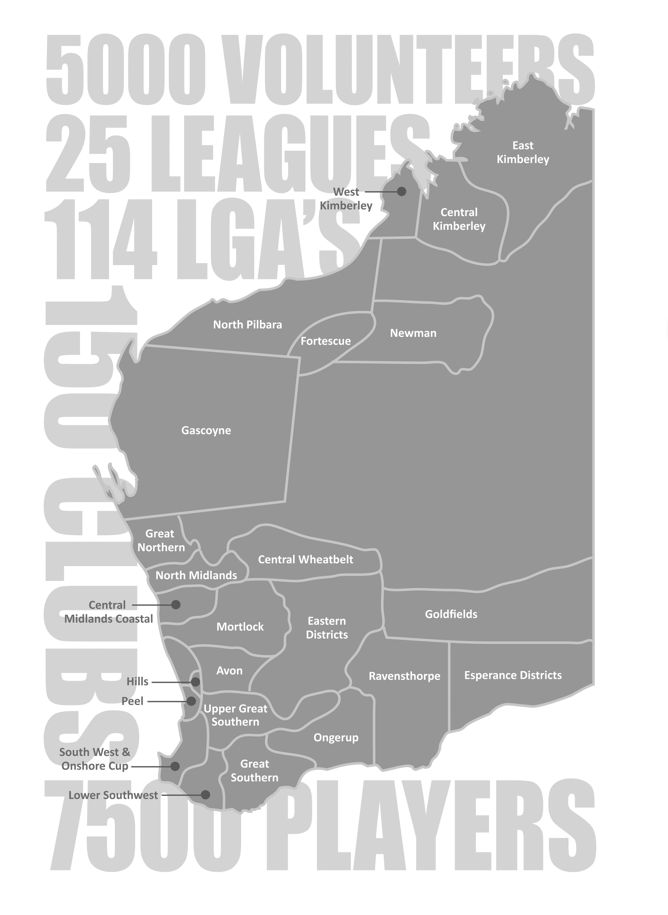
Our Vision
The West Australian Country Football League’s (WACFL) vision is to enhance regional communities through having professionally run football competitions where participants are able to develop within a safe, well governed and successfully administered environment.
Community
Country Football not only provides the state’s regional population the opportunity to participate in a professionally administered sporting competition, but also provides communities with consistent social occurrences that as well as providing entertainment to the community are significant economic drivers.
In 2010 WACFL engaged Street Ryan to carry out a study into the economic impact of football. This report was titled Central Wheatbelt and Great Northern Country Football Economic Impact 2010.
The report stated that the annual economic contribution of local football in the Central Wheatbelt and Great Northern districts in 2010 was estimated to be $4.41 million:
- $1.90 million in Central Wheatbelt and
- $2.51 million in Great Northern.
Using the above two leagues as an average, you could assume that the state-wide economic contribution of senior country football regionally was upwards of $40 million per annum.
Country football has also taken a leadership role within the community using our strong profile to educate players, volunteers, spectators and the community at large on issues such as road safety, men’s health and mental health.
Profile
Across the state, football is the predominant sport. This is especially true in regional Western Australia where other codes have had great difficulty establishing a presence due to football’s stronghold.
As well as the profile of the AFL, the local AFL clubs and the WAFL competition, country football is something that invokes much passion and discussion in the country as towns play against rival towns and sometimes towns divide to play against themselves. With such passion, country football has a strong position and gains great profile regionally through numerous media outlets (radio stations and print media) and public interest.
Coverage
Australian Rules football is the predominant sport in regional Western Australia. Throughout the state there are 25 senior leagues spread from Kununurra in the north east to Esperance in the state’s south.
There are country football competitions across 114 of the state’s 135 regional Local Government Areas (LGAs).
Senior Football
Senior football competitions are for players from the age of 16 to open age. The structure of a competition varies in each area. Some competitions with a strong population of players have Colts, Reserves and League competitions, whilst smaller regions may only have a League competition.
Each of the WACFL’s 25 senior leagues has its own committee/governance structure to manage its competition including clubs, tribunals, umpiring, fixtures, rulings, etc.
There are over 150 senior country football clubs in Western Australia which equates to between six and seven per league on average. Some clubs have numerous grades whilst others only have one team, dependent on population.
There are over 7,500 registered senior country footballers in WA who play in one of the WACFL’s 25 senior competitions. This is quite a specific market that is:-
- between the ages of 16-40
- male
- resides regionally
- physically active
WACFL estimates there are as many as 5,000 volunteers from around the state who help facilitate football in our 25 senior competitions. Volunteer Jobs may include canteen, line marking, gate keeper, team management, committee person, umpiring, scorer, timekeeper, etc.
There are approximately 2,500 matches of senior country football played each season.
There are approximately 100 matches of senior country football played each weekend between April and September.

Segments
With 25 senior leagues spread throughout the state, Country Football covers a number of targeted segments due to the locations of our leagues and the demographics of our players. Some of these segments are listed:
Young Adult Males - Data suggests that 65% of the WACFL’s 7,500 players are aged between 18 and 25 years.
Agricultural - 14 senior country leagues represent regions that are heavily involved with agriculture as a major source of income for their region.
Mining - A handful of senior country leagues are located in regions such as the Pilbara and Goldfields that are heavily involved in the mining sectors. Non-traditional mining areas of the state such as the Kimberley, Esperance, Albany, Gascoyne, Geraldton, etc., have also expanded into the mining sector in recent years which has had an impact on communities, populations and participation.
FIFO workers have become an increasing demographic of country football which has impacted not only mining towns but all country regions as a result of players working on a FIFO basis from their regional location.
Indigenous - There is a relatively high percentage of indigenous players throughout regional leagues, including areas such as the Kimberley which has predominately indigenous players throughout its leagues.
Regional Hubs - Many of the state’s larger leagues are located in key regional areas with solid populations including: Bunbury, Kalgoorlie, Albany, Geraldton, Broome and Esperance.

Levels of Sponsorship
For state-wide and multi league sponsorships, potential sponsors should speak to the WACFL which, as well as having assets available, is able to coordinate sponsorships across leagues in a professional and coordinated manner.
For local level sponsorships, potential sponsors’ first point of contact should be the league or club president. Each league and club has numerous assets for sale which can be tailored to the needs and business requirements of your business.

The Importance of Sponsorship
By sponsoring Country Football at some level, you are assisting the WACFL, our 25 Leagues and 150 Clubs to continue to support those people who not only play country football, but also help facilitate the competitions at some capacity.
Benefits to a regional community of this investment are many and include:-
- Providing regular social activities for regional and isolated communities
- Promoting a health and fitness culture
- Engaging youth in their community and reducing antisocial behaviour
- Allowing communities to participate in sport for a subsidised cost
- Upskilling of volunteers for the benefit of the community
We thank you for taking the time to consider this sponsorship proposal and look forward to working closely with your business to provide mutual benefit to you and grass roots Country Football in Western Australia.
Club Sponsorship
“The level of sponsorship a club can generate significantly affects the amount they are required to charge their players to participate at their club. Other benefits of increased sponsorship are club sustainability ensuring football can continue to be played at that club.
“Sponsorship of our country clubs also helps alleviate pressure on volunteers throughout the year and allows them to concentrate on their key responsibility of managing the club. By doing so, we aim to ensure that our participants are able to develop within a safe, well governed and successfully administered club environment.”
Joe Georgiades, WACFL General Manager
The XXXXX Football Club has created the following sponsorship matrix for the 2015 Season:

Position | Key Benefits/Assets | Partner
Platinum Sponsor | Major Sponsor, logo placement on front of all club jumpers, club polos | Vacant/Not Vacant
Gold Sponsor | Sponsor, logo placement on back of league jumper | Vacant/Not Vacant
Gold Sponsor | Back of Reserves/Colts jumper | Vacant/Not Vacant
Gold Sponsor | Shorts logo | Vacant/Not Vacant
Silver Sponsors (unlimited) | Signage, Website, Newsletters | Vacant/Not Vacant
Silver Sponsors (unlimited) | Contra products, Awards | Vacant/Not Vacant

Filling all the above sponsorships will allow our club to be in the financial position to:-
- Provide a safe framework for players to participate
- Host weekly matches that create significant community investment, interest and pride
- Support the club’s volunteers
- Administer the club
Thank you for taking the time to consider this proposal.

Sponsorship Opportunity
Platinum Club Sponsor
Overview
The XXXXX Football Club was established in XXXX and in 2014 the Club had XX players participate in the XXXXXX competition.
Through having a strong senior football club we are helping support and nurture all levels of sport and recreation in the local community, including junior football and XXXXX other sports.
The XXXXX Football Club believes that there is significant value from both a financial and community perspective through our facilitation of football each week.
In 2015 we have an opportunity to partner with the XXXXXX Football Club as a Platinum Club Sponsor, a partnership that will not only create fantastic exposure for your company, but will also align your company with our Club ensuring you are recognised as a company that invests in its local community at a grass roots level.
Benefits
As a Platinum Club Partner of the XXXXXX Football Club for the 20XX-20XX seasons, we will try our utmost to provide excellent value to our sponsor with benefits including:-
- Recognition as our Major Sponsor
- Logo placement on front of all League level Club jumpers
- Logo recognition on all club polos
- Regular exposure through media outlets including XXXXXXXXX
- Ground signage at all XXXXXX Football Club games
- Signage in weekly Budgets and on Club stationery
- Regular advertising opportunities through newsletters, Budgets and Club social media
- Invitations and recognition at all major XXXXXXX Football Club events
Value
The XXXXXXX Football Club values the above benefits for the 20XX-20XX seasons at $X,000 plus GST.

Thank you for taking the time to consider this proposal.

Sponsorship Opportunity
Gold Club Sponsor (Back of Jumper)
Overview
The XXXXX Football Club was established in XXXX and in 2014 the Club had XX players participate in the XXXXXX competition.
Through having a strong senior football club we are helping support and nurture all levels of sport and recreation in the local community, including junior football and XXXXX other sports.
The XXXXX Football Club believes that there is significant value from both a financial and community perspective through our facilitation of football each week.
In 2015 we have an opportunity to partner with the XXXXXX Football Club as a Gold Club Sponsor, a partnership that will not only create fantastic exposure for your company, but will also align your company with our Club ensuring you are recognised as a company that invests in its local community at a grass roots level.
Benefits
As a Platinum Club Partner of the XXXXXX Football Club for the 20XX-20XX seasons, we will try our utmost to provide excellent value to our sponsor with benefits including:-
- Recognition as a Gold Sponsor
- Logo placement on back of all Club jumpers
- Regular exposure through media outlets including XXXXXXXXX
- Ground signage at all XXXXXX Football Club games
- Signage in weekly Budgets and on Club stationery
- Regular advertising opportunities through newsletters, Budgets and Club social media
- Invitations and recognition at all major XXXXXXX Football Club events
Value
The XXXXXXX Football Club values the above benefits for the 20XX-20XX seasons at $X,000 plus GST.

Thank you for taking the time to consider this proposal.

Sponsorship Opportunity
Gold Club Sponsor (2nd Tier Competition)
Overview
The XXXXX Football Club was established in XXXX and in 2014 the Club had XX players participate in the XXXXXX competition.
Through having a strong senior football club we are helping support and nurture all levels of sport and recreation in the local community, including junior football and XXXXX other sports.
The XXXXX Football Club believes that there is significant value from both a financial and community perspective through our facilitation of football each week.
In 2015 we have an opportunity to partner with the XXXXXX Football Club as a Gold Club Sponsor, a partnership that will not only create fantastic exposure for your company, but will also align your company with our Club ensuring you are recognised as a company that invests in its local community at a grass roots level.
Benefits
As a Gold Club Sponsor of the XXXXXX Football Club for the 20XX-20XX seasons, we will try our utmost to provide excellent value to our sponsor with benefits including:-
- Recognition as a Major Sponsor
- Logo placement on front of all 2nd Tier Competition jumpers
- Regular exposure through media outlets including XXXXXXXXX
- Ground signage at all XXXXXX Football Club games
- Signage in weekly Budgets and on Club stationery
- Regular advertising opportunities through newsletters, Budgets and Club social media
- Invitations and recognition at all major XXXXXXX Football Club events
Value
The XXXXXXX Football Club values the above benefits for the 20XX-20XX seasons at $X,000 plus GST.

Thank you for taking the time to consider this proposal.

Sponsorship Opportunity
Gold Club Sponsor (Shorts)
Overview
The XXXXX Football Club was established in XXXX and in 2014 the Club had XX players participate in the XXXXXX competition.
Through having a strong senior football club we are helping support and nurture all levels of sport and recreation in the local community, including junior football and XXXXX other sports.
The XXXXX Football Club believes that there is significant value from both a financial and community perspective through our facilitation of football each week.
In 2015 we have an opportunity to partner with the XXXXXX Football Club as a Gold Club Sponsor, a partnership that will not only create fantastic exposure for your company, but will also align your company with our Club ensuring you are recognised as a company that invests in its local community at a grass roots level.
Benefits
As a Gold Club Sponsor of the XXXXXX Football Club for the 20XX-20XX seasons, we will try our utmost to provide excellent value to our sponsor with benefits including:-
- Recognition as a Gold Club Sponsor
- Logo placement on all club shorts
- Regular exposure through media outlets including XXXXXXXXX
- Ground signage at all XXXXXX Football Club Games
- Signage in weekly Budgets and on Club stationery
- Regular advertising opportunities through newsletters, Budgets and Club social media
- Invitations and recognition at all major XXXXXXX Football Club events
Value
The XXXXXXX Football Club values the above benefits for the 20XX-20XX seasons at $X,000 plus GST.

Thank you for taking the time to consider this proposal.

Sponsorship Opportunity
Silver Club Sponsor
Overview
The XXXXX Football Club was established in XXXX and in 2014 the Club had XX players participate in the XXXXXX competition.
Through having a strong senior football club we are helping support and nurture all levels of sport and recreation in the local community, including junior football and XXXXX other sports.
The XXXXX Football Club believes that there is significant value from both a financial and community perspective through our facilitation of football each week.
In 2015 we have an opportunity to partner with the XXXXXX Football Club as a Silver Club Partner, a partnership that will not only create fantastic exposure for your company, but will also align your company with our Club ensuring you are recognised as a company that invests in its local community at a grass roots level.
Benefits
As a Gold Club Sponsor of the XXXXXX Football Club for the 20XX-20XX seasons, we will try our utmost to provide excellent value to our sponsor with benefits including:-
- Recognition as a Silver Club Sponsor
- Regular exposure through media outlets including XXXXXXXXX
- Ground signage at all XXXXXX Football Club games
- Signage in weekly Budgets
- Regular advertising opportunities through newsletters, Budgets and Club social media
- Invitations and recognition at all major XXXXXXX Football Club events
Value
The XXXXXXX Football Club values the above benefits for the 20XX-20XX seasons at $X,000 plus GST.

Thank you for taking the time to consider this proposal.

Sponsorship Opportunity
Silver Club Sponsor (Contra Products)
Overview
The XXXXX Football Club was established in XXXX and in 2014 the Club had XX players participate in the XXXXXX competition.
Through having a strong senior football club we are helping support and nurture all levels of sport and recreation in the local community, including junior football and XXXXX other sports.
The XXXXX Football Club believes that there is significant value from both a financial and community perspective through our facilitation of football each week.
In 2015 we have an opportunity to partner with the XXXXXX Football Club as a Silver Club Sponsor, a partnership that will not only create fantastic exposure for your company, but will also align your company with our Club ensuring you are recognised as a company that invests in its local community at a grass roots level.
Benefits
As a Silver Club Sponsor of the XXXXXX Football Club for the 20XX-20XX seasons, we will try our utmost to provide excellent value to our sponsor with benefits including:-
- Recognition as a Silver Club Sponsor
- Exclusive use of your products through our Club
- Promotion of your products and brand through our Club members
- Signage in weekly Budgets
- Regular advertising opportunities through newsletters, Budgets and Club social media
- Invitations and recognition at all major XXXXXXX Football Club events
Value
The XXXXXXX Football Club values the above benefits for the 20XX-20XX seasons at $X,000 plus GST. In exchange for providing the above benefits, the XXXXXXX football club is happy to accept XXXXXXXXXXXXX in contra products in exchange for the above benefits.

Thank you for taking the time to consider this proposal.

COUNTRY FOOTBALL SPONSORSHIP CONTRACT
20XX XXXXX Football Club Sponsorship Agreement

Thank you for your commitment to support the XXXXX Football Club between XXXSTART DATE XXX and XXXFINISH DATE XXXXX.

Upon the signing of the contract the XXXXXXXXX Football Club commits to provide XXXXX ENTER COMPANY NAME XXXXXX with the following benefits:-
- Enter the club’s responsibility in the agreement.
- This needs to be very clear and responsibilities made specific, measurable, achievable, realistic and time manageable (SMART).

Sponsorship Investment
In exchange for the above XXXXXX ENTER COMPANY NAME XXXXX will provide the XXXXXX Football Club with $X,XXX.00 which should be paid no later than XX/XX/XXXX.
(You must outline any other expectations of the sponsor if any.)

Authorisation

_______ _________________
XXXX XXXX
XXXX Football Club President Sponsor XXXXXXX Representative

_______
DATE DATE

